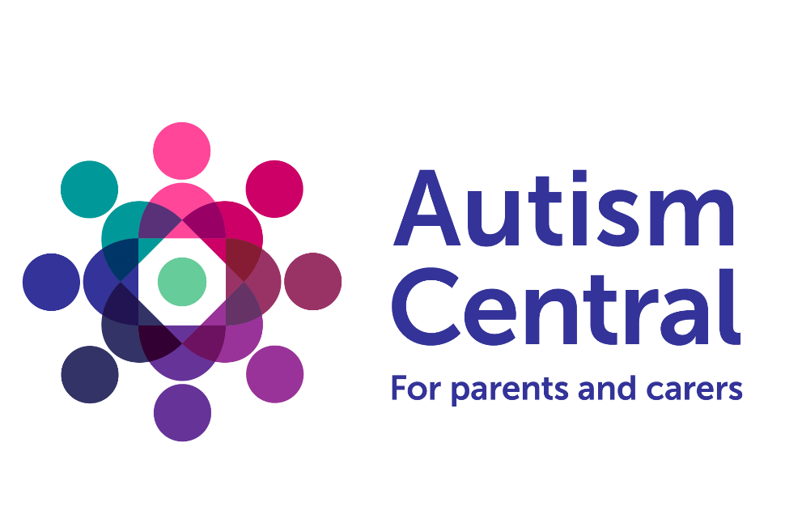
Essex County Council in collaboration with Essex Family Forum are delighted to announce that we are the Regional Hub for the East of England for Autism Central. This is a new programme designed and developed to deliver high-quality and accessible autism information, education and coaching for families, parents, carers, and personal assistants. Autism Central has been commissioned by NHS England’s Workforce, Training and Education Team and is delivered by nine not-for-profit organisations.
Essex County Council are able to offer family members, carers and personal assistants of autistic children and adults a variety of group and individual sessions. These will focus on meeting the needs of autistic people and on signposting to access to local and national services. Sessions will be offered in person and online. These sessions will be facilitated by Peer Educators who are experts by experience and have a good understanding of autism.

This new programme is available to:
- family members of autistic adults and children
- partners/spouses and informal carers of autistic people
- personal assistants of autistic people

If you feel you may benefit, please contact Peer Education Programme
To find out more about how Peer Educators might be able to help you visit https://www.autismcentral.org.uk/find-help or to read more about the programme visit https://www.autismcentral.org.uk/

Essex County Council in collaboration with Essex Family Forum

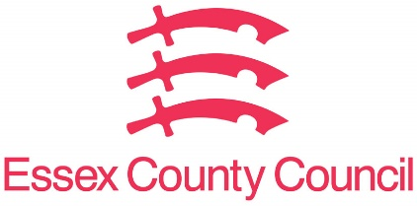 | 

