What to do when I feel angry

My name is ____________________.

Being at home all day can be hard work. Sometimes there are lots of things to do, and people to talk to.
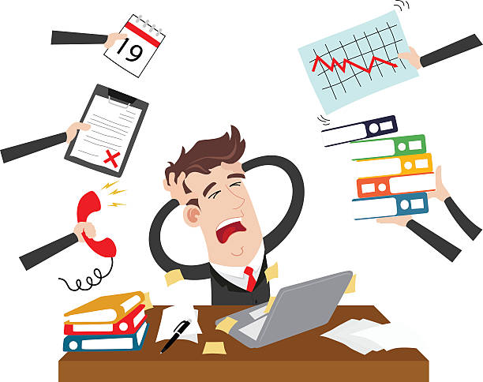



I am good at lots of things. I like ___________, ___________ and ______________. When I am good at something it makes me feel good too. This is great.

Being at home all day means I am with my family. Sometimes we get on well. Sometimes they annoy me and I feel angry.


Anger is a strong feeling that everyone feels sometimes. When we are angry our brain releases lots of energy into our body. It tells our bodies to fight or run away because it thinks we are in danger. Our brain thinks we are in danger and need to get out of it.

That explains why I sometimes want to hit out at others or run away when I am angry. I have a lot of energy and want to protect myself.



Being angry is okay, but hitting others and running away isn’t the best thing to do. It can hurt people and it might be unsafe.

My parents can help me work out what things can make me feel angry. Sometimes it is when people are too close to me. Sometimes it is when people say something that I don’t like. I am learning that I can use my words to ask people to move away or to talk about something else.



- If I do feel angry, I can try to tell my trusted adults that I am angry.
- I can use my words to ask if I can go to my safe place at ____________.
- My trusted adults might ask me if I want a sensory activity which I have put in my box because I know it makes me feel better.
- I can ask to go for a walk with ________ if I want to.

I am learning that being angry is okay and that there are ways we can work together to make angry times better.

Well done me!

